18-798 Image, Video, and Multimedia
Deanna Zhu (dwz)
Jeffrey Lau (jalau)
12/9/2014
Stride Detector: Final Report

Abstract
Amongst older adults, gait and balance disorders are a major cause of falls, which may be fatal or lead to further health complications. Problems are detectable through examination of physical and medical history and physical diagnosis tools like the Timed Up and Go test. Examining gait and balance can help predict future falls as well as help identify points of treatment.

We hope to create a system integrated with the Xbox Kinect to allow individuals to assess the likelihood of having problematic gait and balance issues or provide information that would be helpful to a health professional in making that assessment.
Background
Gait and balance disorders are a major cause of falls amongst older adults. Problems with gait and balance are usually caused by multiple factors and secondary to other medical conditions, such as arthritis or Parkinson disease. Problems with gait and balance include reduced mobility and greater likelihood of falls. In general, issues with gait and balance make daily tasks more difficult or require assistance to complete. As such, gait and balance are associated with increased chance of death and disease.

Detection of gait and balance problems is possible through examination of a person’s health history and physical diagnosis tools like the Timed Up and Go test⁶. Examining gait and balance can help predict future falls as well as help identify points of treatment. Targeted intervention and physical therapy can effectively reduce falls by 30-40%⁶. However, there are few assessment tools to quantitatively characterize gait and problems with it.

Extensive research and analysis has been done on gait as an identifying feature of a person, some methods of which are useful can guide analysis of gait in the context of disorders. Silhouette data provides consistent gait characteristic data⁷. One study looked at the effect of various loads of weight on gait by recording a person walking from left to right frame of the camera and then analyzing the video frames. That study found that max stride length, knee movement, and max arm swing are the most consistent and clear indicators of walking with weight stress⁷. Other studies have looked at the Edinburgh Visual Gait Score (EVGS), which uses video recording to assess change in walking ability over time. The Movement Centre, a center for children in England, uses EVGS to monitor children’s walking and direct therapy treatment ⁸. Another study aimed to look at EVG’s effectiveness in measuring gait when using an ankle-foot orthotic device to help improve walking.

Algorithm Survey
Based on our understanding of prior research methods, we aimed to create a flexible, convenient system that would be helpful to a person who would wish to assess gait and balance problems. We use a Kinect, as it is a powerful tool that can easily be used at home to record a person’s gait.

We first collect data from Kinect. We convert the video-stream data to skeletal form. Then we compare the data to known walking samples. Our algorithm classifies the walk based on the shortest euclidean distance and picks the closest sample as the final classification.

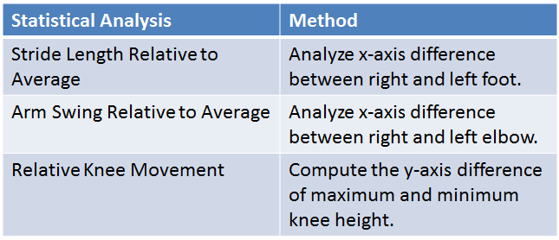
Our results display a video of the closest classification as well as statistics related to the sample walk (% match, max stride length, % knee movement, and max arm swing).

Algorithm
For our application, we designed an algorithm based on the Euclidian distances between various motion energy images (MEI). These motion energy images include those created from the BVH files we have collected within our database as well as images generated from the collection of skeletal information from the Kinect API. The figure below shows a base model of the algorithm.
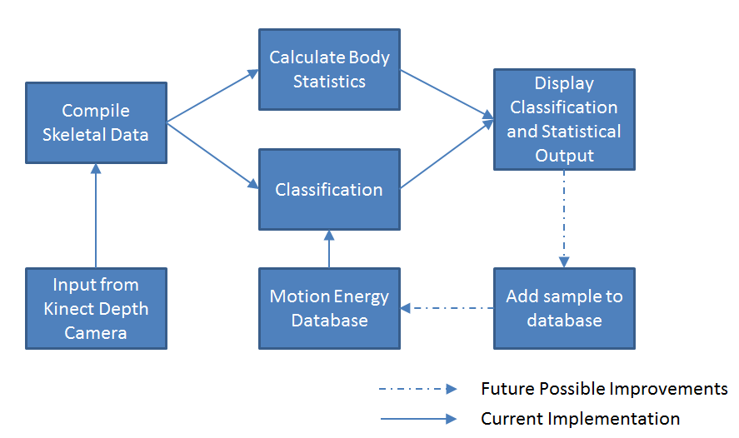
Although the specifications of the Kinect’s depth camera lists data input as collected at around 30 frames per second, we found that it slows down significantly as we attempt to draw out the skeletal frame for our user’s reference. Thus, within our application, we ask for 50 frames from the Kinect’s depth camera. This translates to an average of 3 seconds for each run. During the collection process, although we take a small amount of processing power to draw the present skeletal frame for the user, we defer the processing of the skeletal data to a motion energy image. We decided to do so in order to keep our system as efficient as possible.

After collecting the necessary skeletal data, we create a motion energy image and “score” the image. An image score is determined by the number of white pixels within a row or column vector of the image. Thus, every image has two score sequences. The figure below shows two examples of images and their respective column sequence scores.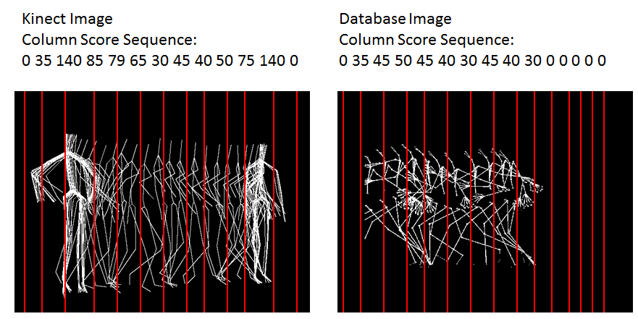

Because the resulting image from the Kinect can differ based on many factors (the user’s height, distance from the Kinect, etc), we choose to extract the sequence of nonzero numbers (ignoring the blank space around the motion energy image) and directly compare the sequences. This way, we ensure that we’re comparing the motion patterns as opposed to comparing the images as a whole. Additionally, because we have extracted the pattern to compare, we are also able to compare motion energy images even if the motion of the individual has changed. While in our current algorithm, we ask that the user move from right to left, it is entirely possible to compare the sequences assuming the user is walking in a direction opposite to the images stored within our database.

When comparing the motion energy images, we compute a comparison score for each sequence based on the Euclidean distance value between the sample image and the database image. The difference between the numerical values found at corresponding indexes are squared and summed. Afterward, we determine the square root of the sum to obtain the final score for one image comparison. This is repeated for every image in the database. Using this simple method, we can begin to objectively compare sequences.

Next, we compare the resulting image from the Kinect to the numerous other images that we have collected and stored within our database. When all images have been scored, we simply select the lowest score and its associated image to report back to the user. Each unique image within our database has already been classified with a specific title that relates to the issue that was relevant to the test subject at the time of its collection. This process of scoring and classification can be seen in the figure below.
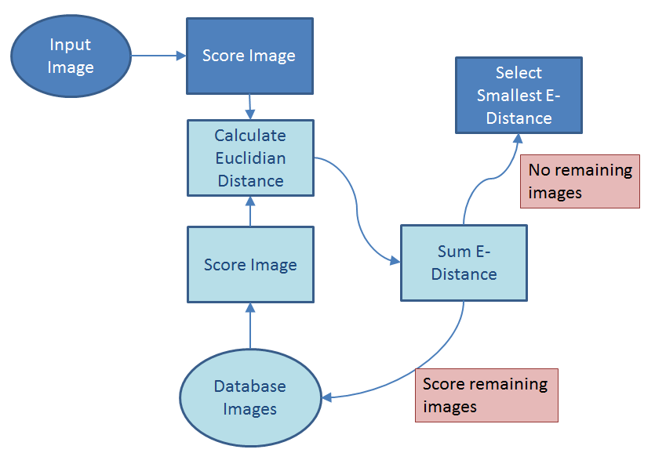
Our algorithm has limitations, as the accuracy of our system is reliant on both the accuracy and precision of our database as well as the skeletal information collected by the Kinect. A common issue that was observed with the data collected with the Kinect is when various joints become switched due to confusion from the depth camera. As a result, the final motion energy image becomes inaccurate. However, our comparison and classification algorithm attempts to diminish the effects of these issues by comparing and scoring sequences in their entirety. Additionally, many of the images within our database have a distinct pattern so that classification can be unambiguously correct or incorrect.

Below is an example of our application GUI and the output that would be displayed to the user after classifying a walk.
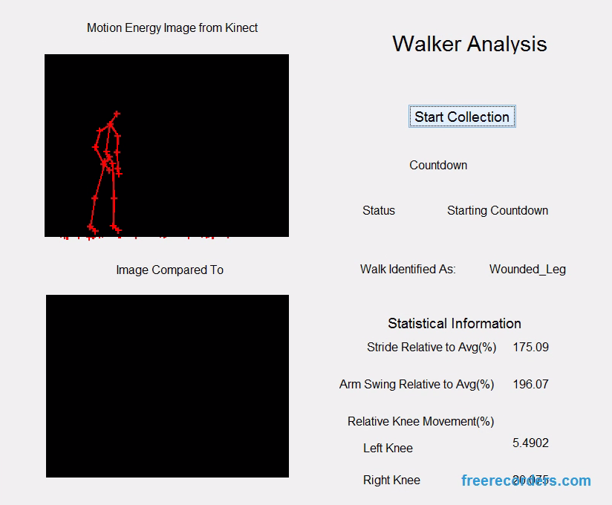

Results
In our data collection and experiments, we collect several useful parameters that are useful to classification but can also be expanded upon and referenced by other research groups for the future analysis of gait. We collected several MEI images from data in the CMU Graphics Lab’s Motion Capture library to add variation to the database.

The following table relates the average range of knee movement to the specific type of walk.
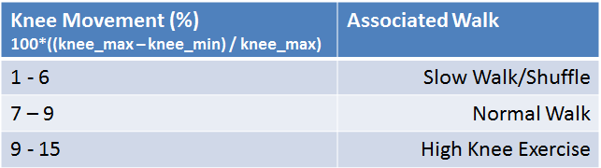

The following table categorizes the average range of stride to a type of walk based on already-classified data from the Motion Capture library ⁴.
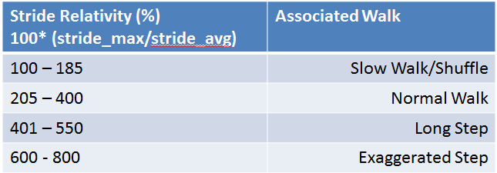

While the length of stride has already been shown in previous research to reflect abnormal gait, we have found a way obtain similar data that supports this information. Our incorporation of this data into our project is helpful for users to be able to track their progress. Perhaps over the course of several weeks or months of rehabilitation, a patient will see their stride or knee range of motion increase with improvement or decrease or stay the same if they are not making improvements.

Finally, we used our system to classify real walking samples. The following table shows the classification accuracy of some test results where we mimic different types of walks. Each type of walk was performed and classified 5 times. For walks like “wounded leg” or “arthritis prone”, our walks did not accurately reflect that type of walk because we were unable to find patients with wounded legs or arthritis.
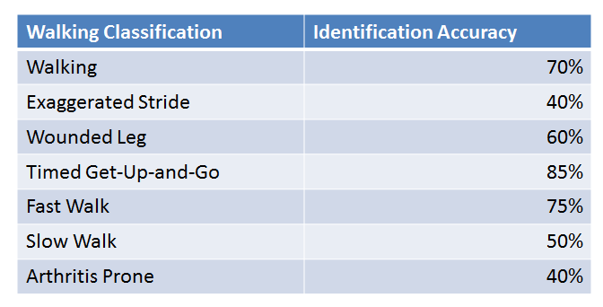

Here is an example output of a correctly classified “wounded leg”
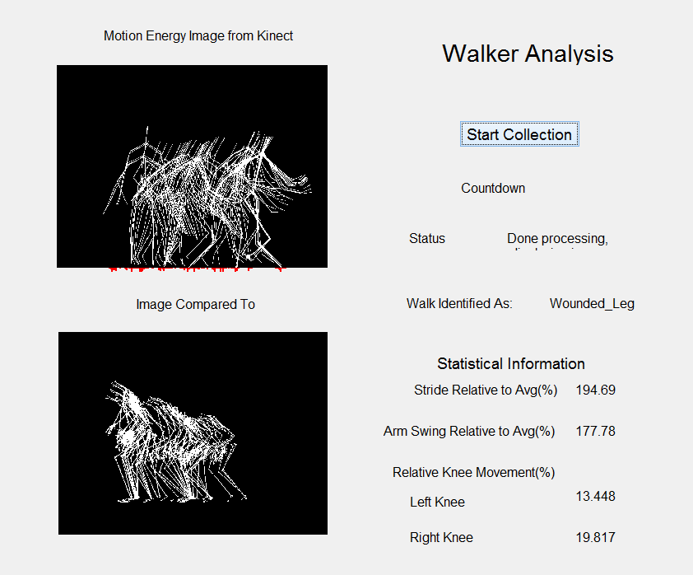

And here is an example of a misclassified “wounded leg”

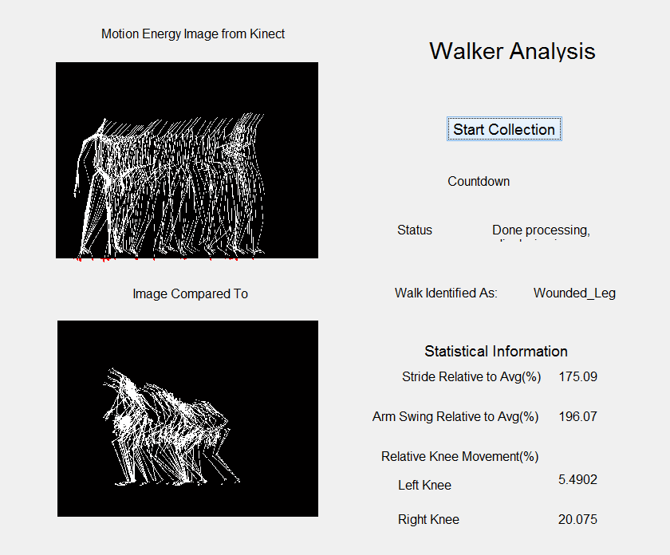

Mathematical Analysis
The following are equations that we utilized to extract information from the depth image stream from the Kinect:

For the following equations, we refer to data sets that comprise of skeletal data points collected from each frame received from the Kinect depth camera.

1) Average Stride Length
For data set S = S₁ + S₂ + S₃ + … + S_{n}
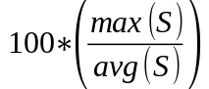
2) Average Arm Swing Length
For data set A = A₁ + A₂ + A₃ + … + A_{n}
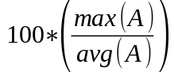
3) Average Knee Height
For data set K = K₁ + K₂ + K₃ + … + K_{n}
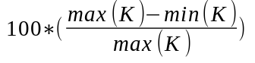
4) Image Scoring
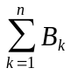
(where B is the grayscale value of a pixel . It is either 0 or 1 for our purposes. N is the total number of pixels within either the row or column of the image being scored.)
5) Comparison and Classification
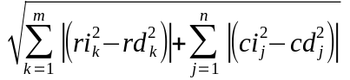
(where N is the number of rows, M is the number of columns, Ri and Ci represent the sequence of row and column data from the Kinect image. Rd and Cd represent the sequence of row and column data from the database image.)

Algorithmic Comparisons
Our algorithm is based on the 2-D data build from the Kinect’s depth camera is primitive compared to other algorithms used to track and recognize movement in the market. However, it is a first step in automating an evaluation that typically requires direct observation and analysis from a trained professional. If a more portable and efficient programming language other than MATLAB were used, our program could have the capacity to become faster and more accurate as well. Other algorithms make use of the 3D information associated with the skeletal data to make their classifications more accurate as well. With enough time and resources, our algorithm could be extended to classify the presence of gait issues but identify the specific problems that would guide physical therapy.

With the ability to correct misclassified samples, we can also allow our system to add new gait patterns into the database as samples are correctly classified or corrected, helping to increase the accuracy of matching.

Conclusion
We believe that our system prototype is a valid proof of concept in quantitatively identifying the presence of gait issues in individual walks. Our hope is that in the future, applications similar to ours would be able to be easily and inexpensively installed in households across the world and allow doctors and physical therapists to work with patients from their home. For patients whose mobility is already very limited, whether through injury or disease, this could make a difference in their recovery or remission. Patients would also be able to evaluate themselves using our program and track their progress in order to encourage themselves through their progression of treatment.

References

- "Acquiring Image and Skeletal Data Using Kinect." Matlab Documentation. MathWorks, n.d. Web. 20 Nov. 2014.
- "Bvhacker: The Free Bvh File Editing Tool." Bvhacker. N.p., n.d. Web. 09 Dec. 2014.
- Kumar, Sanjay, Dinesh Kumar, Arun Sharma, and Neil McLachlan. Visual Hand Gestures Classification Using Temporal Motion Templates and Wavelet Transforms. School of Electrical and Computer Engineering. RMIT University, 2004. Web. 20 Nov. 2014.
- "Motion Capture Library." CMU Graphics Lab. Carnegie Mellon University, n.d. Web.
- Putnam, Rachel, Jason Wening, and Dan Hasso. "Effectiveness of Edinburgh Visual Gait Score as a Valid Measure to Assess Influence of an Ankle Foot Orthosis on Adult Gait." (2014): n. pag. American Academy of Orthotists and Prosthetists. 1 Mar. 2014. Web. 20 Nov. 2014.
- Salzman, Brooke. "Gait and Balance Disorders in Older Adults." - American Family Physician. AAFP, 1 July 2010. Web. 08 Dec. 2014.
- Wittman, Michael G., James M. Ward, and Patrick J. Flynn. Visual Analysis of the Effects of Load Carriage on Gait. Tech. no. 46556. University of Notre Dame, n.d. Web. 20 Nov. 2014.
- “Edinburgh Visual Gait Score.” The Movement Centre. http://www.the-movement-centre.co.uk/case-studies/edinburgh-visual-gait-score/

